**PROJECT DESIGN PHASE -2**

**DATA FLOW DIAGRAM & USER STORIES**

|  |  |
| --- | --- |
| DATE | 15 OCTOBER 2022 |
| TEAM ID | PNT2022TMID36938 |
| PROJECT | SMART FASHION RECOMMENDER APPLICATION |
| MAXIMUM MARK | 4 Marks |

**Data flow diagram:**

A data flow diagram is a traditional visual representation of the information flows within a system. A neat and clear DFD can depict the right amount of the system requirement graphically. It shows how data enters and leaves the system,what changes the information, and where data is stored.

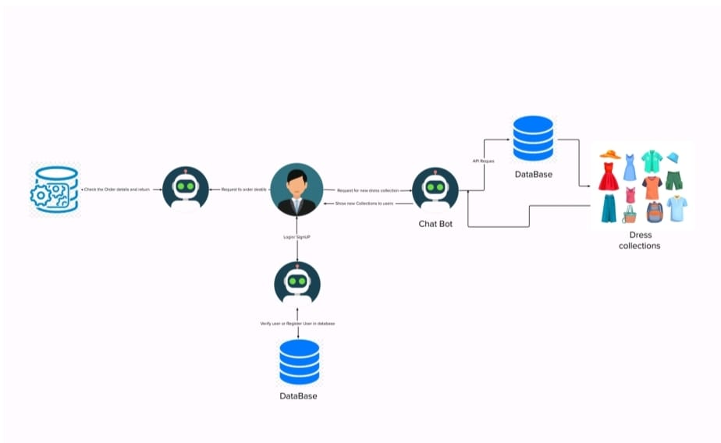

**USER STORIES:**

